MAR 3023 Marketing Management

Session H1 (CRN 25451)
Class Policies & Course Syllabus
Fall 2023

Course: MAR 3023 – Marketing Management
Campus: West
Semester/Term: Spring 2024 – H1 Session (CRN 25451)
Prerequisites: None
Credit Hours: 3
Class Meeting Day/Time: Online
Classroom: Online
Professor: John Ferris
Email: jferris8@valenciacollege.edu
Office Phone: N/A
Office: N/A
Office Hours: Email and on Valencia’s Faculty FrontDoor
______________________________________________________________________

COURSE DESCRIPTION
This course covers the study of how firms create and communicate value in order to build and maintain customer relationships while benefiting the organization and its stakeholders. Emphasis is placed on the functions, institutions, and basic problems in marketing of goods and services in our domestic economy and abroad.

Credit hours: 3
Prerequisites: Admission to the B.A.S degree in Business and Organizational Leadership.

COURSE MAJOR LEARNING OUTCOMES (MLO)
Course outcomes are set by Valencia College and reinforce the Student Competencies of Think, Value, Act, and Communicate. For more information select: http://valenciacollege.edu/competencies. The MLOs for this course are to:

- Classify the internal and external factors that affect the marketing environment and assess their impact on competitive strategy.
- Make the pricing calculations and apply related pricing strategies to make the pricing decisions contained in a marketing plan.
- Understand how markets are segmented and how target markets are selected.
- Identify advantages and disadvantages of communications options and apply related strategies to make the communications decisions contained in a marketing plan.
- Identify the steps in the new product development process and apply product related strategies to make the product and branding decisions contained in a marketing plan.
- Identify the steps in the strategic planning process, recognize the types of competitive strategies, and indicate how products are positioned for competitive advantage.
- Identify the steps in the buying decision making process that differ across buying situations.
- Identify the steps in the marketing research process and recognize how various marketing research techniques can be used to answer marketing questions.
______________________________________________________________________

EDUCATIONAL MATERIALS
Text: You are not required to purchase a textbook for this course. Instead, we will be using the following free Open Education Resources (OER) ebook.
Principles of Business: Marketing
Supplemental: In addition to the ebook, we will be discussing current events and using supplemental resources such as journal articles and videos. Links for these supplemental resources will be provided on Canvas.

Software: All course materials and communication tools will be accessed via your Canvas account for this course. As a Valencia student, you have access to Microsoft Office (Word, Excel, PowerPoint) free for personal use. It is recommended that you download the desktop version of MS Office to avoid formatting issues in Canvas. You can learn more about accessing these applications in Atlas, on the "My Atlas" tab, right hand column, under "Microsoft Office for Personal Use."

COURSE EVALUATION
The purpose of the evaluation strategy for this course is to measure your Knowledge, Skills, and Abilities (KSAs) as a student of the Bachelor of Applied Science in Business and Organizational Leadership (BASBOL) program. Final grades are not rounded up. The final grade is as it appears in the gradebook in Canvas. Please keep track of your progress, complete all assignments, and finish strong in order to gain the highest grade possible.

MLOs will be assessed by either 1) Knowledge check quizzes, 2) Discussions, 3) Assignments, 4) Final evaluation, or a combination. Below is a general description for each assessment:
- Knowledge check quizzes are open text or notes and are intended as self-checks to make sure you understand the course content for any given week or module. You will have two attempts on each quiz.
- Discussions are based on main topics in the chapter readings, journal articles, videos, current events, or supplemental materials. Discussions require you to post a substantive response to the initial discussion question(s) and a substantive response to at least one classmate’s posting. Substantive means responses that add depth and detail to the discussions, stimulate thought, and further the discussions. Responses must be in your own words, use correct spelling/grammar, and properly cited with references when required. It is recommended that you first type your post in MS Word, run a spellcheck/grammar, and then copy/paste the posting in Canvas.
- Assignments may consist of writing exercises, presentations, research, or creative project. The assignments provide students with opportunities to apply course concepts associated with learning outcomes. All submissions will be checked for proper spelling/grammar and plagiarism.
- The Final evaluation may consist of a written response to essay questions or a capstone project, which encompasses a major learning outcome of the course. Specific instructions and a rubric will be provided when the Final evaluation is posted.

EVALUATION
Assessment | Total Points | Percentage of Grade
Knowledge Check Quizzes  (4 Quizzes, 25 points each) | 100 | 10%
Discussions  (4 Discussions, 50 points each) | 200 | 20%
Assignments  (4 Assignments, 100 points each) | 400 | 40%
Final evaluation | 300 | 30%
Total | 1000 | 100%

GRADING SCALE
Points | Percentage | Grade
900- 1000 | 90% – 100% | A
800 - 899 | 80% - 89% | B
700 - 799 | 70% - 79% | C
600 - 699 | 60% - 69% | D
0 - 600 | Below 60% | F

CLASS POLICIES
Students must adhere to the following policies to remain in good standing.
- Attendance: If you are absent more than two weeks in the semester, you are subject to withdrawal. Attendance is recorded each week you submit a Knowledge check quiz, Discussion, Assignment, or Final evaluation. You are marked absent each week you do not submit any of the weekly assignments. Logging into Canvas without submitting something does not count for attendance. The academic week runs from Monday at 12:00am EST to Sunday at 11:59pm EST.

If the syllabus notes additional activities that must be completed during a given week or time period for the student to be viewed as having “attended” the course, those instructions apply in addition to the minimal requirements listed above.

- Late submissions: The student is responsible for submitting ALL assessments before the due dates outlined in the course schedule or Canvas. Late submissions will not be accepted. If you are unable to participate in the course due to illness, family emergency, etc., please communicate with me as soon as possible in order to create a plan for the best course of action.

- Student participation: Students must have an active Atlas account and check their Atlas e-mails regularly as to not miss any important messages from the Professor. Missed messages via Atlas or any other medium (In-class, Canvas, etc.) may affect your grade. Students are expected to do their own work. Failure to so may result in Academic Dishonesty.

- Students with Disabilities: Students with disabilities who qualify for academic accommodations must provide a letter from the Office for Students with Disabilities (OSD) and discuss specific needs with the Professor, preferably during the first two weeks of class. The OSD determines accommodations based on appropriate documentation of disabilities (West Campus SSB 102, ext. 1523).

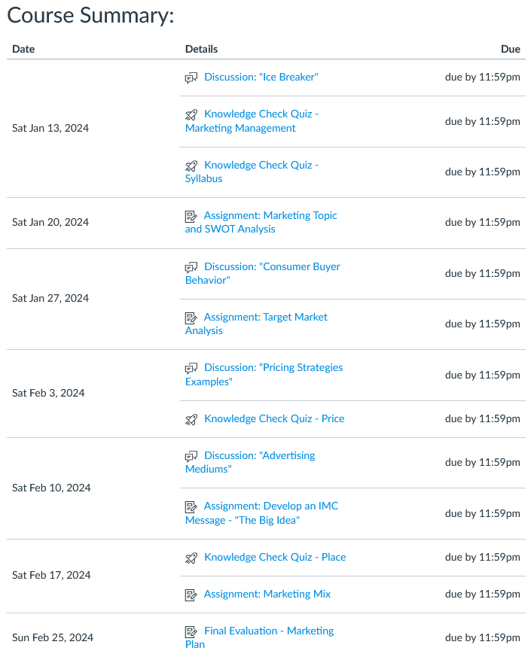

DISCLAIMER
The schedule, procedures, and assignments are subject to change in the event of extenuating circumstances. However, any such change will be clearly announced. Such changes are designed to deal with unforeseen circumstances that arise during the course. The changes will be intended to benefit the student and will not significantly add to the rigor of the course.

Valencia College Policies

Academic Dishonesty
All forms of academic dishonesty are prohibited at Valencia College. Academic dishonesty includes, but is not limited to, acts or attempted acts of plagiarism, cheating, furnishing false information, forgery, alteration or misuse of documents, misconduct during a testing situation, facilitating academic dishonesty, and misuse of identification with intent to defraud or deceive.
All work submitted by students is expected to be the result of the students' individual thoughts, research, and self-expression. Whenever a student uses ideas, wording, or organization from another source, the source shall be appropriately acknowledged.

Student Code of Conduct
Valencia College is dedicated to the advancement of knowledge and learning and also to the development of responsible personal and social conduct. The primary purpose for the maintenance of discipline in the College setting is to support a civil environment conducive to learning and inquiry.

Students will be expected to adhere to the Valencia College Student LifeMap Handbook as it references Valencia College's Policy #6HX28:08-03. The link to the LifeMap Student Handbook: https://valenciacollege.edu/students/student-services/documents/student-handbook.pdf

Student Assistance Program
Valencia College has contracted with a private and confidential counseling service to provide
short-term assistance to credit students who need to resolve problems that are affecting their college performance. Examples might include: stress, relationship/family issues, alcohol/drug problems, eating disorders, depression, and gender issues. Students who are experiencing any of these issues and who are enrolled in credit classes at Valencia should call the toll-free number 1-800-878-5470 to speak to a professional counselor. Following is the link to the website: http://catalog.valenciacollege.edu/studentservices/baycarestudentassistanceservices/

Statement of Support for Students with Food/Housing/Financial Needs
Any student who has difficulty accessing sufficient food to eat, or who lacks a safe and stable place to live, and believes this may affect his or her performance in the course, is urged to meet with a Counselor in the Advising Center. for information about resources that may be available from the college or community. Following is the link to the website: https://valenciacollege.edu/students/advising-counseling/

Withdrawal Policy
The student is permitted to withdraw from a class on or before the withdrawal deadline as published in the College calendar. A student is not permitted to withdraw from a class after the withdrawal deadline. If you are thinking about withdrawing from this course, I ask that you please contact me first. I also highly recommend you contact your academic adviser and financial aid counselor as students on financial aid may be adversely affected by withdrawing from classes. The Professor is permitted to withdraw a student from the class for violation of the Professor’s attendance policy with written notification to the student prior to the beginning of the final exam period.
A student who withdraws from a class before the withdrawal deadline will receive a grade of "W." A student who is withdrawn by a Professor will receive a grade of "W." A student who is withdrawn for administrative reasons at any time will receive a grade of "W" or other grade as determined in consultation with the Professor. Any student who withdraws or is withdrawn from a class during a third or subsequent attempt in the same course will be assigned a grade of "F".
Final course grades of "A", "B", "C", "D", or "F" shall be assigned based upon the student's academic achievement on all course work.
If you drop the course(s) by the Drop/Refund Deadline, all tuition and refundable fees will be refunded. (Application and certain other fees are not refundable.) See (College Policy: 6HX28:06-08.1 Student Fees and Refunds) for more information.

Note to International Students (F-1 or J-1 Visa)
Please be advised that withdrawal from this course due to attendance may result in the termination of your visa status if you fall below the full-time enrollment requirement of 12 credit hours. Contact Valencia’s International Student Services office for more information. Following is the link to the website: https://international.valenciacollege.edu/

“No Show” Status
Class attendance is required beginning with the first class meeting. If you do not attend the first class meeting, you may be withdrawn from the class as a “no show.” Students who are not actively participating in an online class and/or do not submit the first assignment by the scheduled due date must be withdrawn by the instructor at the end of the first week as a "no show". If you are withdrawn as a “no show,” you will be financially responsible for the class and a final grade of “WN” will appear on your transcript for the course. The policy can be located at the following link: http://catalog.valenciacollege.edu/academicpoliciesprocedures/classattendance/

